Software needed
(*edit*)
It is assumed that the user has installed the following software before starting with SXT analysis
- HEASoft (https://heasarc.gsfc.nasa.gov/lheasoft/install.html)
- SXTMKARF (http://www.tifr.res.in/~astrosat_sxt/page1_data_analysis.php)
- SXTEVTMERGERTOOL (the link is the same as above)
- SAO ds9 (http://ds9.si.edu/site/Download.html)
Once the user has installed the above software, and they are working as expected, the user can proceed with the processing mentioned below.

Getting Clean Event Files

- Get the level 2 tar.gz files.

- Untar the files using the command: tar xzvf filename.tar.gz

- To untar all the files together, list the files in a directory using: ls *tar.gz > filename.sh

- To open the file containing the list: gedit filename.sh

- To get a list of all the clean event files:

a. Copy into gedit any clean event filename.
Eg: 20160331_T01_112T01_9000000406_level2_02740_V1.0/sxt/02740/sxt.01/AS1T01_112T01_9000000406sxtPC00_level2_cl.evt and save the file with a filename. Eg: clnevtlist.txt

b. Replace the font in red with * .

c. Use the command: ls path_of_the_directory/*/sxt/*/sxt.01/*cl.evt > cleanevtlist.txt to get the list of clean event files from all orbits into a single file.

Merging the clean event files:

- Download SXTEVTMERGERTOOL from the following link: http://www.tifr.res.in/~astrosat_sxt/page1.php

- Extract the files.

- The readme file contains the commands for installing and merging the clean event files of different orbits into one clean event file.

If everything is done as instructed in the document, the user should have a clean event file for both modes.
Note, do not merge PC and FW mode data with each other.

Analyzing the data

Getting the image, light curve and spectrum:

We start by using XSELECT (a package in HEASoft) to get the image, light curve and spectrum of the source.
(*edit*)
The following link provides a *detailed description of the commands used to get the image, light curve and spectrum of the source:
https://heasarc.gsfc.nasa.gov/docs/software/lheasoft/ftools/xselect/xselect.html

*Note that the commands are highlighted as bold in the following sections:
(*edit*)
- First, one needs to enter the name of the directory in which the merged/single clean event file is placed. That is done by using the command >read event after which the user will be asked for the directory adderess, upon entering it, (enter the complete adderess of the driver from home directory) , XSELECT will ask for the file name with extension.

- To get the image of the source, use the commands >extract image >plot image.

- To select a region, click on the window that opened upon entering the plot image command. In the toolbar, click on edit, and region, (if it is not selected by default), on doing that go to the region option in the tool bar and select the shape needed, (for starters we would be using the circle and annulus shape for our filters), on doing the above, the user should see a green circle (or whatever shape selected) pop up in the image upon clicking on it. The user can now change the dimensions of the region. Now, in order to see what shape the region is selected and what are it’s dimensions, select the region and click on the information pannel. This should open a new window which would give the user details about the region selected. On the bottom of the region window, the user should see a part that shows the radius of the region file in degrees, click on the “degrees” and change it to display the dimensions in arc min. Now, the standard dimensions that one uses for SXT analysis are: 1). 5 arc min (am) radius circle (also called 5am extraction) from the center of the source in FW mode. 2) 5am outer radius and 1am inner radius annulus (shape of the region) also known as 5 am with 1am exclusion for FW mode. For PC mode the region dimensions are 1) 16 am extraction with 1 am central exclusion, 2). 16 am extraction with 2 am central exclusion and finally 3). 16 am extraction with 3 am central exclusion. This makes a total of 5 region files, 2 for FW mode and 3 for PC mode, which need to be saved. These are selected so that we are able to match the dimensions of the arfs we would be using later.

- The command for applying region filters is >filter region nameofsavedregionfile.reg. The image has to be re-extracted and re-plotted, for the user to see the effect. Note that the user is expected to enter the file path to the region file as well, if the region file is saved in a directory different than the working directory, this applies to all instances where the user is supposed to enter the name of a file.

- The image can be saved using the command >save image and it gets saved with an extension .img .

3. To get the light curve, use the commands >extract curve >plot curve. The curve can be saved using the command >save curve and it gets saved with an extension .lc

4. To get the spectrum, use commands >extract spectrum >plot spectrum. The spectrum can be saved using the command >save spectrum and it gets saved with an extension .pha.

5. The image, the curve and the spectrum can also be saved using the command >extract all >save all savename

(*edit*)
Getting the RAWX, RAWY coordinates:
In order to be able to use SXTMKARF to obtain offaxis arfs, the user would have to obtain the RAWX and RAWY coordinates of the center of the object as well. This is done with the help of the following commands:
- Remove the region filter which is applied using the command > clear region filter.

- Use the command > set xyname rawx rawy > extract image > plot image. Choose a region (circle), place the region such that the region covers the center of the source. Select information, as mentioned previously. And find the RAW centroid co-ordinates by selecting the region and looking at the information window. Save save these coordinates, since we will need it later for sxtmkarf.

- Now, when finding the centroid, the user is supposed to be very careful since even a deviation of few pixels from the actual centroid might change the normalization (output) significantly. One way to find the ideal (or close to ideal) centroid is to select the region and from the region tool bar drop down menu, keep clicking on centroid, until the region stops moving. Once the region is stationary, we have the centroid coordinates that would give us close to ideal value.

Analyzing the spectrum:

- For analysing the spectrum, the xspec tool is used.

- XSPEC requires the spectrum data file (.pha), the background file (.pha), response file (.rmf) and the arf file (.arf) as inputs.

- Using the following link, one can find the appropriate model for fitting the data with. The chapter “Walks through XSPEC” explains the analysis with an example.

https://heasarc.gsfc.nasa.gov/xanadu/xspec/XspecManual.pdf

ARF, Background and RMF needed:

On -axis ARF files:
FW - central 1 arcmin removal – extraction radius 5 arc min: sxt_fw_excl01_v02.arf
FW – without removal - extraction radius 5 arc min: sxt_fw_v02.arf
PC – central 1 arcmin removal - extraction radius 16 arc min: sxt_pc_excl01_v03.arf
PC – central 2 arcmin removal - extraction radius 16 arc min: sxt_pc_excl02_v03.arf
PC – central 3 arcmin removal - extraction radius 16 arc min: sxt_pc_excl03_v03.arf

Background File: SkyBkg_comb_EL3p5_Cl_Rd16p0_v01.pha (same for PC and FW mode)

RMF File: sxt_pc_mat_g0to12.rmf (same for PC and FW mode)

Creating off-axis ARFs from on-axis ARFs using SXTMKARF tool:
- To run the program first select the file sxtmkarf.sh, a text editor will open. Most of the instructions are given there.

- Enter the .pha file name (which we created using XSELECT), enter the name for the output ARF file which will get created after running the code, enter the RMF and on-axis ARF files. Also, change the ARF names indicated after 'cphead'.

- Type chmod 755 sxtmkarf.sh, which gives the permission to run the script. Then run ./sxtmkarf.sh . Note, that all the files should be in the same directory for ease of use.

- After running ./sxtmkarf, the code should ask for RAWX, RAWY co-ordinates. Enter the RAWX and RAWY coordinates that we obtained in the previous section.

- Example:
sxtmkarf phafile=crab_pc_1arcmin_spec.pha outfile=sxt_pc_excl01_v03_offax.arf rmffile=sxt_pc_mat_g0to12.rmf inarffile=sxt_pc_excl01_v03.arf expofile=NONE psfflag=N vigfile=CALDB srcx=-1 srcy=-1 chatter=4 clobber=Y history=Y
cphead sxt_pc_excl01_v03.arf+1 sxt_pc_excl01_v03_offax.arf+1

*Replace the red text with your own file names (with path, if in a different directory)

Commands used to analyze Crab data:

The following commands were used in in sequence in XSPEC to analyze the data (details about the commands used is given in the Xspec manual, link of which is given above):

grppha command: > grppha
a. Enter the original .pha spectrum file (filename.pha)
b. Change the name of original .pha file and enter the new name. (filename_grp.pha)
c. Enter the background file name. (> command chkkey backfile filename.pha)
d. Enter the response filename. (> command chkkey respfile filename.rmf)
e. Enter the arf filename. (> command chkkey ancrfile filename.arf)
f. Enter the number of channels to be grouped. (command > group min 60)
e. Enter exit.
This will create a .pha file by the name filename_grp.pha in the working directory, use this file as data file in the next step.

First, the data file i.e. the .pha spectrum file has to be entered.
> data filename_grp.pha.
Subsequently, the background file, the response file and the ancillary response file
> back SkyBkg_comb_EL3p5_Cl_Rd16p0_v01.pha ,
> response sxt_pc_mat_g0to12.rmf
> arf filename.arf (corresponding to the region filter used to make the data file)
The arf used is the offaxis arf created using sxtmkarf.

Energy range selected: 0.7 keV – 7.0 keV using the command >setplot energy.

The spectral model used was (tbabs*powerlaw).
- Command > model tbabs*powerlaw
- Enter the values of nH, PhoIndex, norm as 0.21, 2.14, 10.4 and fit.

gainfit command: > gain fit (*edit*)
After using the gainfit command, a slope prompt appears. The slope should be entered as 1,-1. After entering the slope, an appropriate offset value is generated and the slope value is frozen to 1.

Abundance: > abund wilm

Xsect : > xsect bcmc

Systematic command:
For Crab, the systematic error was set to 0.02, i.e. 2%.
> systematic 0.02

Fit command:
> fit

Error command:
Determines the error in the three parameters.
> error 1 2 3

1. Expected output for PC mode data:

Observation dates: 31.03.2016

Orbit Used: 02741

a. 1 arcmin removal: extraction radius 16 arcmin:

On-axis ARF used: sxt_pc_excl01_v03.arf

The plot below was obtained for an off-axis arf (created with sxtmkarf) using the commands mentioned above.

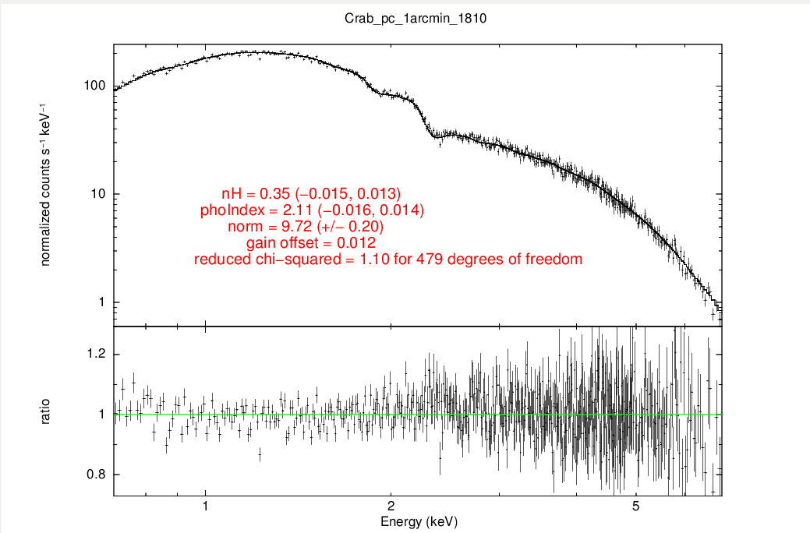

Similar plots can be obtained for:
PC – central 2 arcmin removal - extraction radius 16 arc min: sxt_pc_excl02_v03.arf
PC – central 3 arcmin removal - extraction radius 16 arc min: sxt_pc_excl03_v03.arf

2. FW Mode:

Observation dates: 31.03.2016

Orbits to be Merged: 02762, 02766, 02767, 02768 (for close to ideal value)

ARFs to be used:

1. FW - central 1 arcmin removal – extraction radius 5 arc min: sxt_fw_excl01_v02.arf
2. FW – without removal - extraction radius 5 arc min: sxt_fw_v02.arf

Similar procedure and commands have to be followed to get the plots in FW mode.

Important Links:

- For using XSELECT: http://www.swift.ac.uk/analysis/xrt/xselect.php

- AstroSat POC: http://www.tifr.res.in/~astrosat_sxt/home.php

- Dictionary for most of the terms used: http://cxc.harvard.edu/ciao/dictionary/

